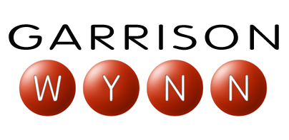
INTRODUCTION

Our speaker today has presented to some of the worlds most effective leaders and field professionals, including Multi-Billion-Dollar manufacturers and top service providers. His clients include: Southern Company, Exxon, Pacific Gas and Electric, Shell, The Depart of the Defense and NASA.

He is the author of the Amazon.com Bestseller “The REAL truth about success” and has been a weekly contributor to the Washington Post. He is also a former professional stand-up comedian who has hosted television specials and national radio programs, and a former fortune 500 corp. manager and chemical plant explosion survivor who has developed and marketed industrial safety products that are still being sold in 30 countries.

Please welcome Garrison Wynn.

